
CSA3023/CSE3023/CSM3023
WEB-BASED APPLICATION DEVELOPMENT
Lab Modules
Wan Nural Jawahir Hj Wan Yussof, Rabiei Mamat,
Mohd Arizal Shamsil Mat Rifin
& Muhammad Syaffiq Hazari
Contents
List of Figures iii
- DEVELOPMENT ENVIRONMENT SETUP FOR JAVA WEB
APPLICATIONS 1 1.1 Objectives 1
  - Introduction 1
  - Software Requirements 2
  - Task 1: Install Java Development Kit (JDK) 2
    - Step 1: Download JDK 2
    - Step 2: Install JDK 2
    - Step 3: Verify JDK Installation 2
  - Task 2: Install XAMPP 3
    - Step 1: Download XAMPP 3
    - Step 2: Install XAMPP without Tomcat 4
    - Step 3: Verify XAMPP Installation 9
  - Task 3: Change the Default Root Password of MySQL 11
    - Step 1: Start Apache and MySQL Services 11
    - Step 2: Run Command 12
  - Task 4: Tomcat 9 Installation 18
    - Step 1: Download Apache Tomcat 9 18
    - Step 2: Extract Apache Tomcat 9 19
    - Step 3: Start Tomcat Server 19
    - Step 4: Verify Installation 20
  - Task 5: NetBeans IDE Installation 21
    - Step 1: Download Apache NetBeans 29 21
    - Step 2: Extract and Install NetBeans 29 21
    - Step 3: Configure NetBeans 29 23
    - Step 5: Configure Tomcat in NetBeans 23
  - Task 6: Writing a Simple Java Servlet 26
    - Step 1: Create New Project 26
    - Step 2: Create New Servlet 29
    - Step 3: Run Servlet 32
  - Task 7: Writing a Simple JSP Program 34
    - Step 1: Create a New Project 34
    - Step 2: Create a New JSP File 36
    - Step 3: Run JSP File 39
  - Task 8: Use Java Reference Datatype/Class Wrapper in JSP 41
    - Step 1: Create a New JSP File 41
i
  - Exercise 43
- SERVLET: DATA SHARING AND DATABASE MANAGEMENT 45
  - Objectives 45
  - Introduction 46
  - Software Requirements 46
  - Task 1: Data Sharing in Servlet 46
    - Step 1: Project Setup 46
    - Step 2: Create HTML Login Page 48
    - Step 3: Create a Login Servlet 48
    - Step 4: Create an Account Servlet 51
    - Step 5: Run the Project 52
2.5 Task 2: Creating A Table in MySQL Database 53
    - Step 1: Start Apache and MySQL 53
    - Step 2: Create a New Database 53
    - Step 3: Create a New MySQL Table 53
2.6 Task 3: Setting the Environment of Web Application for Database
Connection 54
    - Step 1: Create a New Web Application Project 54
    - Step 2: Prepare the MySQL Connector 55
2.7 Task 4: Using Servlets for Database CRUD Operations 57
    - Step 1: Create HTML Form for Data Entry 57
    - Step 2: Create the Insert Servlet (Create) 58
    - Step 3: Create the View Servlet (Read) 59
    - Step 4: Create the Delete Servlet (Delete) 62
    - Step 5: Create the Update Servlet (Update) 63
2.8 Task 5: Using Servlets, DAO and Java Beans for Database CRUD Operations 65
    - Step 1: Copy and Rename the Project 66
    - Step 2: Create the User JavaBean (Model) 66
    - Step 3: Create the Data Access Object (UserDAO) 68
    - Step 4: Modify the Existing Servlets (Controller) 72
2.9 Exercise 77
ii
List of Figures
  - XAMPP Download Platform 3
  - XAMPP Setup Wizard Startup Screen 5
  - XAMPP Select Components 5
  - XAMPP Installation Directory 6
  - XAMPP Language 7
  - XAMPP Installation Ready 7
  - XAMPP Installation Progress 8
  - XAMPP Installation Finish 8
  - XAMPP Control Panel 9
  - XAMPP Control Panel Running 10
  - XAMPP Dashboard 10
  - phpMyAdmin Interface 11
  - XAMPP Control Panel-Click Shell 11
  - Verify Password 12
  - Error Page 13
  - Apache Tomcat9 Download Page 18
  - Start Tomcat Server 19
  - Apache Tomcat Homepage 20
  - Apache NetBeans 29 Download Page 21
  - Extract netbeans-29-bin.zip 22
  - Netbean Executable File 22
  - Netbean IDE GUI 23
  - Configure Server 24
  - Add Server 24
  - Add Server 25
  - Add Server 25
  - Add Server 26
  - Create New Project 27
  - Create New Web Application 27
  - Enter Project Details 28
  - Create New Servlet 29
  - Name the Servlet 30
  - Configure Servlet Deployment 30
  - HelloServlet.java File 31
  - processRequest() Method 31
  - Modified processRequest() Method 31
  - Run the Servlet 32
iii
  - Dialog Box Call to /HelloServlet 32
  - Output 33
  - Modified doGet() Method 33
  - Dialog Box with Passing Parameter 34
  - Output 34
  - Create New Web Application 35
  - Enter Project Details 36
  - Configure the Server 36
  - Create a New JSP File 37
  - Enter Name and Location 37
  - Modified JSP File 38
  - Compile JSP File 38
  - Compile JSP File 38
  - Run JSP File 39
  - Output 40
  - Start/Stop Apache Tomcat 40
  - Create useJavaObject.jsp 41
  - useJavaObject.jsp 42
  - Output 43
  - Create New Servlet 49
  - Create Login Servlet 49
  - Configure servlet deployment 50
  - Creating the “CRUDusingServlet” Project 55
  - Downloading MySQL Connector/J 55
  - Extracting the MySQL Connector/J Archive 56
  - Adding External Library to Project 56
  - Importing MySQL Connector/J Library 57
iv

Lab Module 2

SERVLET: DATA SHARING AND DATABASE MANAGEMENT
2.1
Objectives
The primary goal of this lab is to familiarize students with dynamic web application development using Java Servlets and JDBC. By the end of this session, students should be able to:
- Implement Data Sharing in Servlet: Share data across different components of a web application using request, session, or ServletContext attributes (e.g., setAttribute() and getAttribute()).
- Creating a table in MySQL Database: Execute SQL CREATE TABLE statements to define the database schema, data types, and constraints for storing application data.
- Setting the Environment of Web Application for Database Connection: Configure the JDBC driver, define the database URL, and set up the necessary credentials to establish a successful connection between the Java application and MySQL.
- Using Servlets for Database CRUD Operations: Implement Create, Read, Update, and Delete operations within Servlet methods (such as doGet and doPost) by executing SQL queries via the JDBC API (PreparedStatement and ResultSet).
2.2
Introduction
Java Servlets are robust server-side components used to create dynamic, platform-independent web applications. When combined with Java Database Connectivity (JDBC), Servlets empower developers to interact seamlessly with relational databases, allowing the application to process complex business logic, manage data persistence, and generate dynamic responses based on client requests.
This lab focuses on the core mechanics of integrating a Java web application with a MySQL database. Students will explore the essential steps to configure the database connection environment, create database tables, and implement effective data sharing strategies across Servlet components. Furthermore, the lab emphasizes practical application by guiding students through the development of fully functional Create, Read, Update, and Delete (CRUD) operations using the JDBC API.
2.3
Software Requirements
To successfully complete the tasks outlined in this manual, the following software environment is required:
Software | Description
Java Development Kit (JDK) | Version 8 or higher (required to compile Java classes and Servlets).
Integrated Development Environment (IDE) | Apache NetBeans.
Web Server | Apache Tomcat 8.0 or GlassFish Server 4.1.
Web Browser | Any modern browser (e.g., Google Chrome, Mozilla Firefox, Microsoft Edge) for testing and viewing output.

2.4 Task 1: Data Sharing in Servlet
Objective: To use servlet for request forwarding and data sharing.
Problem Description: Write a login form and a servlet to authenticate a user.
Estimated time: 30 minutes

2.4.1 Step 1: Project Setup
- Create a directory:
F:\[YOUR_COURSE_CODE]-[MATRICNUMBER]
Note: Replace [YOUR_COURSE_CODE] with your course code (e.g: CSA3023/ CSE3023 / CSM3023) and [MATRICNUMBER] with your actual matric number (e.g., SXXXXX). Create this directory only if you have not created it yet.
- Go to the directory and create a subdirectory named:
Lab 2
- Open your Apache NetBeans IDE.
- Navigate to the top menu and select:
  - File → New Project...
- Select:
  - Java Web → Web Application
Click Next.
- Enter the project details:
  - Project Name: ServletDataSharing
  - Project Location: F:\[YOUR_COURSE_CODE]-[MATRICNUMBER]\Lab 2 Click Next.
- Configure the server:
  - Choose Apache Tomcat as the server.
Click Finish.

2.4.2 Step 2: Create HTML Login Page
- You will see your project structure on the left side of your NetBeans editor. Next, you will create an HTML file for a login page.
- Right-click your project name (ServletDataSharing) → New → HTML File.
- Name your HTML file as: login Click Finish.
- Type the HTML markups into your login.html.
<!DOCTYPE html>
<html lang="en">
<head>
<meta charset="UTF-8">
<meta name="viewport" content="width=device-width, initial-scale=1.0"> <title>Login Page</title>
</head>
<body>
<h2>Login</h2>
<form action="LoginServlet" method="POST">
<label for="username">Username:</label>
<input type="text" id="username" name="username"><br><br>
<label for="password">Password:</label>
<input type="password" id="password" name="password"><br><br>
<input type="submit" value="Login"> </form> </body> </html>

2.4.3 Step 3: Create a Login Servlet
Next, we are going to create a servlet to process the username and password insert by the user on the login form. We start it by creating a new file for our servlet. Follow the steps below:
- Right-click on the project.
- Select New → Servlet.
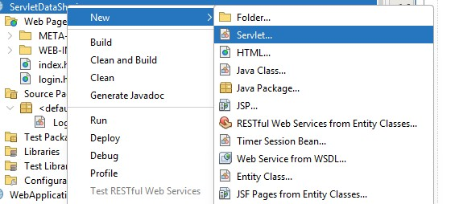
Figure 2.1: Create New Servlet
- Enter the servlet name: LoginServlet.
- Enter the package name: SourcePackages.
- Click Finish.
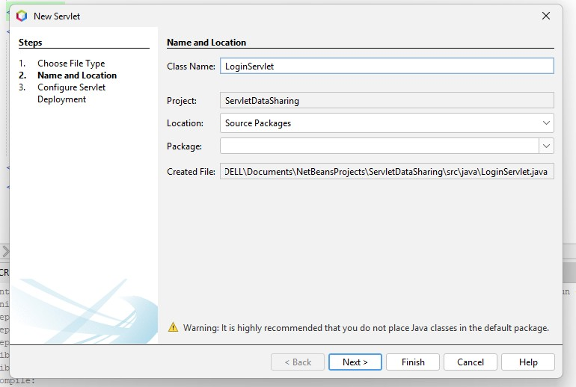
Figure 2.2: Create Login Servlet
- Configure the servlet deployment by clicking Add Information in the deployment descriptor.
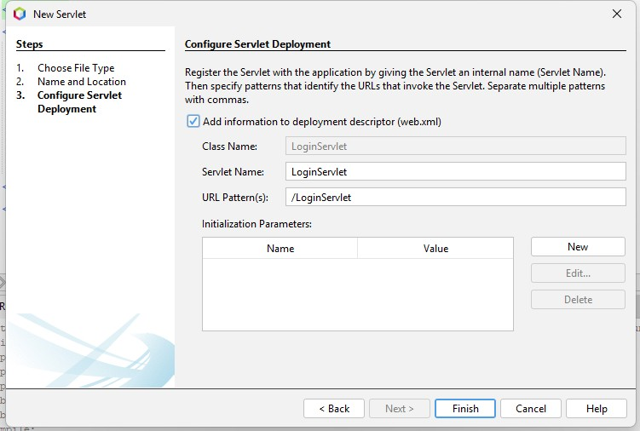
Figure 2.3: Configure servlet deployment
- Implement the doPost() method in LoginServlet as follows:
protected void doPost(HttpServletRequest request, HttpServletResponse response) throws ServletException, IOException {
String user = request.getParameter("username");
String pass = request.getParameter("password");
// Semakan kata laluan (Authentication) if (user.equals("Ahmad") && pass.equals("4567")) {
// Data Sharing: Menyimpan maklumat tambahan ke dalam 'request'
request.setAttribute("accountType", "Premium Student"); request.setAttribute("email", "ahmad@siswa.edu.my");
// Request Forwarding ke AccountServlet
RequestDispatcher rd = request.getRequestDispatcher
("AccountServlet"); rd.forward(request, response);
} else if (user.equals("Siti") && pass.equals("1234")) {
// Contoh untuk pengguna lain request.setAttribute("accountType", "Standard Student"); request.setAttribute("email", "siti@siswa.edu.my");
RequestDispatcher rd = request.getRequestDispatcher
("AccountServlet"); rd.forward(request, response);
} else {
// Jika login gagal
response.setContentType("text/html"); PrintWriter out = response.getWriter(); out.println("<h3 style='color:red'>Login Failed! Invalid credentials.</h3>");
out.println("<a href='login.html'>Try Again</a>");
} }

2.4.4 Step 4: Create an Account Servlet
Next, create a servlet to retrieve users’ account information and display it in the browser. Repeat the previous steps to create a new servlet named AccountServlet, and configure the details as shown below:
//Servlet AccountServle import java.io.IOException; import java.io.PrintWriter; import javax.servlet.ServletException; import javax.servlet.http.HttpServlet; import javax.servlet.http.HttpServletRequest; import javax.servlet.http.HttpServletResponse;
public class AccountServlet extends HttpServlet { protected void doPost(HttpServletRequest request, HttpServletResponse response) throws ServletException, IOException {
response.setContentType("text/html"); PrintWriter out = response.getWriter();
// Mengambil semula parameter dari borang HTML asal String username = request.getParameter("username");
} | // Mengambil data yang dikongsi oleh LoginServlet  String accountType = (String) request.getAttribute("accountType");  String email = (String) request.getAttribute("email");  out.println("<html><body>");  out.println("<h2>Account Information</h2>"); out.println("<hr>");  out.println("<p><strong>Welcome, " + username + "!</strong></p>"); out.println("<p><b>Email:</b> " + email + "</p>");  out.println("<p><b>Account Type:</b> " + accountType + "</p>"); out.println("<br>");  out.println("<a href='login.html'>Logout</a>"); out.println("</body></html>");  }

2.4.5 Step 5: Run the Project
- Run the project. The output will be displayed in a web browser. Enter the username Ahmad and the password 4567, then click Login.
- If all previous steps have been completed correctly, the account information for the user Ahmad will be displayed. Repeat Step 1 using other user credentials and observe the results.
Reflections
- What have you learned from this exercise?
- What are the common methods used in Java Servlet?

2.5 Task 2: Creating A Table in MySQL Database
Objective: To create a MySQL table to store user credentials.
Problem Description: Prepare a user table to be used in Web Application.
Estimated time: 30 minutes

2.5.1 Step 1: Start Apache and MySQL
- Open the XAMPP Control Panel.
- Click Start for both Apache and MySQL services.

2.5.2 Step 2: Create a New Database
- Click the Admin button for MySQL.
- Create a new database schema using your course code. Example: CSE3023

2.5.3 Step 3: Create a New MySQL Table
- After the database has been created, we will now create a table named users. This table consists of four columns.
- Open the SQL tab in phpMyAdmin, then execute the following command by clicking the Go button:
USE CSE3023;
CREATE TABLE users ( id INT AUTO_INCREMENT PRIMARY KEY,
username VARCHAR(100), password VARCHAR(100), roles VARCHAR(50)
);
- The newly created table will appear on the left panel in phpMyAdmin.
- Insert some sample data into the users table.
- After executing the SQL command, phpMyAdmin will display an autogenerated query. To view the inserted data, click the Browse tab.
- The records stored in the users table will be displayed. This indicates that the table has been successfully created and populated.
Note: In a real-world application, passwords must be securely encrypted (e.g., hashed) and should never be stored or displayed in plain text.

2.6 Task 3: Setting the Environment of Web Application for Database Connection
Objective: To set up a proper environment for integrating web application to the database.
Problem Description: Import MySQL JDBC Library to an existing project. Estimated time: 5 minutes

2.6.1 Step 1: Create a New Web Application Project
- Open NetBeans IDE.
- Create a new web application project and name it CRUDusingServlet.
- Select Apache Tomcat as the application server.
- Choose Java EE Web as the project type.
- Click Next, then click Finish. The web application project will be created successfully.
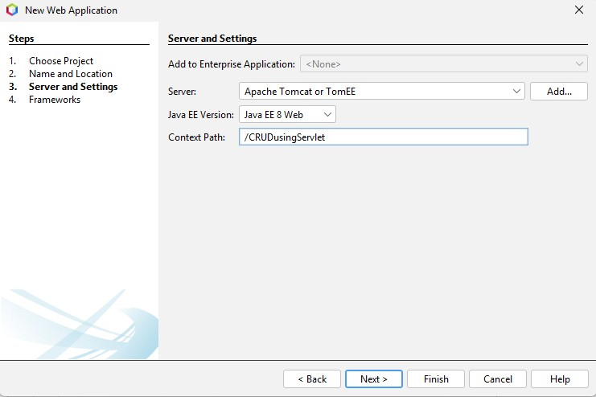
Figure 2.4: Creating the “CRUDusingServlet” Project

2.6.2 Step 2: Prepare the MySQL Connector
- Open your web browser and navigate to the official MySQL Connector/J download page:
https://dev.mysql.com/downloads/connector/j/
- From the Operating System drop-down menu, select Platform Independent.
- Click the Download button for the ZIP archive file. If prompted to log in or sign up, click the ”No thanks, just start my download.” link at the bottom of the page.
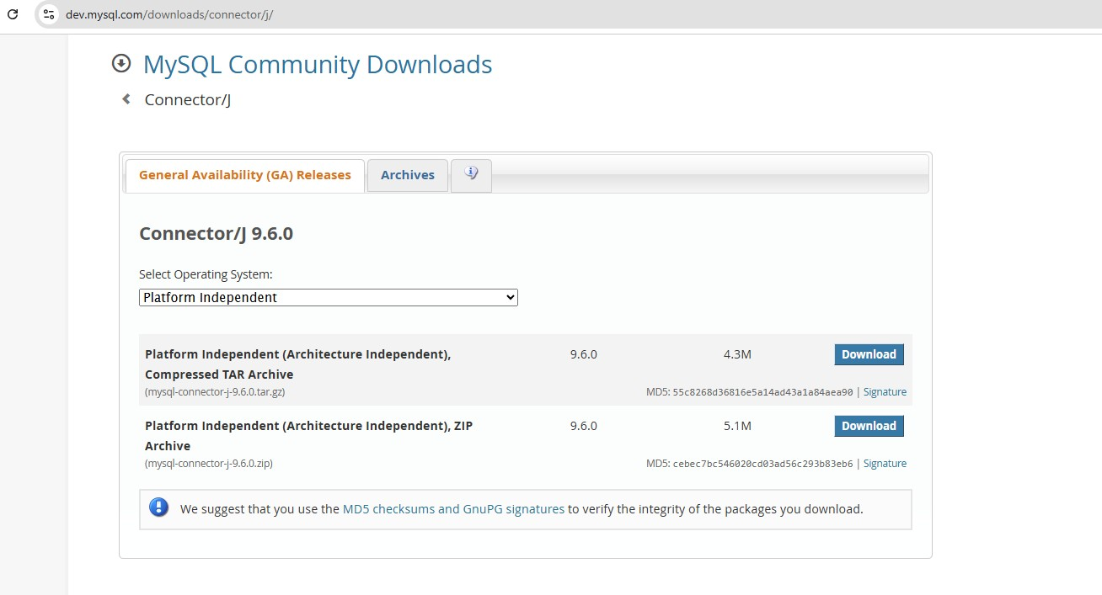
Figure 2.5: Downloading MySQL Connector/J
- Once the file has been downloaded, extract the ZIP archive to a known location on your computer (e.g., C:\MySQL-Connector\).
- Open the extracted folder and locate the JAR file (e.g., mysql-connector-j-9.x.x.jar).
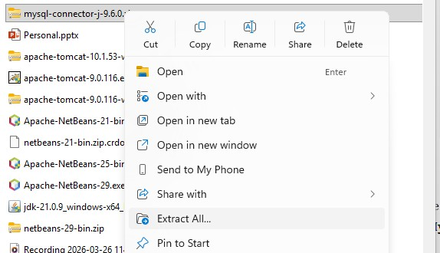
Figure 2.6: Extracting the MySQL Connector/J Archive
- Return to NetBeans IDE.
- In the Projects window, locate and expand your project folder.
- Right-click on the Libraries node and select Add JAR/Folder....
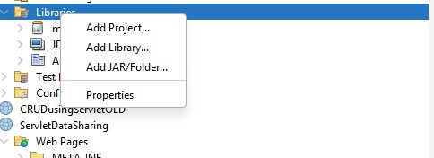
Figure 2.7: Adding External Library to Project
- In the file chooser window, navigate to the extracted MySQL Connector folder.
- Select the JAR file (e.g., mysql-connector-j-9.x.x.jar) and click Open.
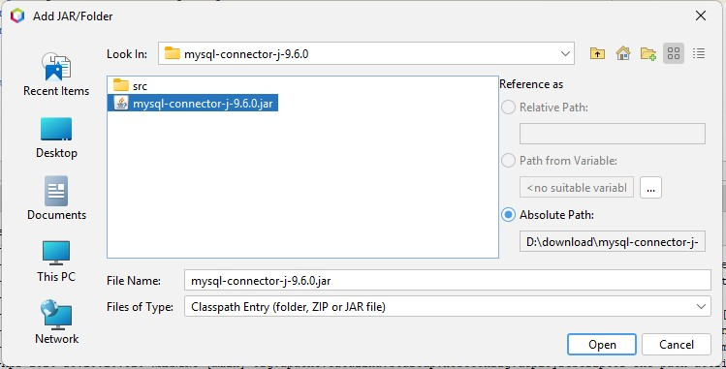
Figure 2.8: Importing MySQL Connector/J Library
- To verify the installation, expand the Libraries node in your project. The MySQL Connector JAR file should now be listed.
- The application is now ready to connect to the MySQL database and execute SQL queries.

2.7 Task 4: Using Servlets for Database CRUD Operations
Objective: To implement Create, Read, Update, and Delete operations within Servlet methods using the JDBC API.
Problem Description: Develop a web application with Servlets to manage records (insert, view, update, and delete) in a MySQL database.
Estimated time: 60 minutes

2.7.1 Step 1: Create HTML Form for Data Entry
- In the Projects window, right-click on the Web Pages folder → New → HTML
File....
- Name the file index and click Finish.
- Open the index.html file and create an HTML form to capture user data, including Username, Password, and Roles.
- Configure the form by setting the action attribute to point to the servlet (e.g., action="InsertServlet") and set the method to POST.
- Add a Submit button to allow users to send the data to the server for processing.

2.7.2 Step 2: Create the Insert Servlet (Create)
- In the Source Packages node, right-click → New → Servlet....
- Name the servlet InsertServlet, assign it to an appropriate package (e.g., com.lab.controller), and click Finish.
- In the doPost() method, retrieve the form data using request.getParameter() for the fields username, password, and roles.
- Load the MySQL JDBC driver using Class.forName(...) and establish a database connection using DriverManager.getConnection() with your database (e.g., CSE3023).
- Create a PreparedStatement to execute the following SQL query:
INSERT INTO users (username, password, roles) VALUES (?, ?, ?)
- Set the retrieved form values into the query parameters and execute the statement using executeUpdate().
- Upon successful insertion, redirect the user to the data listing page using:
response.sendRedirect("ViewServlet");
- The complete code snippet for the doPost() method in InsertServlet is shown below:
package com.lab.controller;
import java.io.IOException; import java.io.PrintWriter; import javax.servlet.ServletException; import javax.servlet.http.HttpServlet; import javax.servlet.http.HttpServletRequest; import javax.servlet.http.HttpServletResponse; import java.sql.Connection; import java.sql.DriverManager; import java.sql.PreparedStatement;
public class InsertServlet extends HttpServlet { protected void doPost(HttpServletRequest request, HttpServletResponse response) throws ServletException, IOException {
} | String username = request.getParameter("username");  String password = request.getParameter("password"); String roles = request.getParameter("roles");  try {  Class.forName("com.mysql.cj.jdbc.Driver");  Connection conn = DriverManager.getConnection("jdbc:mysql:// localhost:3306/CSE3023", "root", "admin");  String sql = "INSERT INTO users (username, password, roles)  VALUES (?, ?, ?)";  PreparedStatement pstmt = conn.prepareStatement(sql); pstmt.setString(1, username); pstmt.setString(2, password); pstmt.setString(3, roles); pstmt.executeUpdate();  pstmt.close(); conn.close(); response.sendRedirect("ViewServlet");  } catch (Exception e) {  e.printStackTrace();  } }

2.7.3 Step 3: Create the View Servlet (Read)
- Create a new servlet and name it ViewServlet.
- In the doGet() method, establish a connection to the database in the same way as in Step 2.
- Prepare a SQL query to fetch all user records from the database table:
SELECT * FROM users;
- Execute the query using executeQuery() and store the results in a ResultSet object.
- Iterate through the ResultSet using a while (rs.next()) loop to access each record.
- Dynamically generate an HTML table using out.println() to display the retrieved data (ID, Username, Password, Roles) row by row.
- Important: Add two additional columns in the HTML table for Edit and Delete actions. These should be hyperlinks pointing to UpdateServlet and DeleteServlet, passing the record’s ID in the URL. Example:
<a href='DeleteServlet?id=1'>Delete</a>
<a href='UpdateServlet?id=1'>Edit</a>
- The complete code snippet for the doGet() method in ViewServlet is shown below:
package com.lab.controller;
import java.io.IOException; import java.io.PrintWriter; import java.sql.Connection; import java.sql.DriverManager; import java.sql.ResultSet; import java.sql.Statement;
import javax.servlet.ServletException;
import javax.servlet.http.HttpServlet; import javax.servlet.http.HttpServletRequest; import javax.servlet.http.HttpServletResponse;
public class ViewServlet extends HttpServlet {
@Override
protected void doGet(HttpServletRequest request, HttpServletResponse response) throws ServletException, IOException {
response.setContentType("text/html"); PrintWriter out = response.getWriter();

out.println("<h2>User List</h2>");
out.println("<table border='1'><tr><th>ID</th><th>Username</th><th>
Password </th><th>Role</th><th>Actions</th></tr>");
try {
Class.forName("com.mysql.cj.jdbc.Driver");
Connection conn = DriverManager.getConnection("jdbc:mysql:// localhost:3306/CSE3023", "root", "admin");
Statement stmt = conn.createStatement();
ResultSet rs = stmt.executeQuery("SELECT * FROM users");
while (rs.next()) { int id = rs.getInt("id"); out.println("<tr>");
out.println("<td>" + id + "</td>"); out.println("<td>" + rs.getString("username") + "</td>"); // Untuk lab, kita paparkan password. Untuk sistem sebenar, jangan paparkan! out.println("<td>" + rs.getString("password") + "</td>"); out.println("<td>" + rs.getString("roles") + "</td>"); out.println("<td><a href='UpdateServlet?id=" + id + "'> Edit</a> | ");
out.println("<a href='DeleteServlet?id=" + id + "'> Delete</a></td>"); out.println("</tr>");
}
out.println("</table>");
out.println("<br><a href='index.html'>Add New User</a>");
rs.close(); stmt.close(); conn.close();
} catch (Exception e) {
e.printStackTrace();
}
} }

2.7.4 Step 4: Create the Delete Servlet (Delete)
- Create a new servlet and name it DeleteServlet.
- In the doGet() method, retrieve the record ID passed from the URL using:
String id = request.getParameter("id");
- Establish a database connection and prepare a SQL statement to delete the record:
DELETE FROM users WHERE id = ?
- Set the retrieved ID as the parameter for the PreparedStatement and execute the query using executeUpdate().
- After successful deletion, redirect the user back to the updated table view:
response.sendRedirect("ViewServlet");
- The complete code snippet for the doGet() method in DeleteServlet is shown below:
public class DeleteServlet extends HttpServlet { protected void doGet(HttpServletRequest request, HttpServletResponse response) throws ServletException, IOException { String id = request.getParameter("id");
try {
Class.forName("com.mysql.cj.jdbc.Driver");
Connection conn = DriverManager.getConnection("jdbc:mysql:// localhost:3306/CSE3023", "root", "admin");
String sql = "DELETE FROM users WHERE id=?";
PreparedStatement pstmt = conn.prepareStatement(sql); pstmt.setInt(1, Integer.parseInt(id)); pstmt.executeUpdate();
pstmt.close(); conn.close(); response.sendRedirect("ViewServlet");

} | } catch (Exception e) {  e.printStackTrace();  } }

2.7.5 Step 5: Create the Update Servlet (Update)
- Create a new servlet and name it UpdateServlet.
- In the doGet() method:
    - Retrieve the record ID from the URL using request.getParameter("id").
    - Fetch the corresponding user record from the database.
    - Populate an HTML form with the retrieved data so the user can edit the existing values.
    - Set the form’s action attribute to point to UpdateServlet and use the POST method for submission.
//UpdateServlet doGet() Method: Display Form for Editing Record
// Paparkan borang dengan data sedia ada protected void doGet(HttpServletRequest request, HttpServletResponse response) throws ServletException, IOException {
response.setContentType("text/html"); PrintWriter out = response.getWriter(); String id = request.getParameter("id");
try {
Class.forName("com.mysql.cj.jdbc.Driver");
Connection conn = DriverManager.getConnection("jdbc:mysql:// localhost:3306/CSE3023", "root", "admin2128");
String sql = "SELECT * FROM users WHERE id=?";
PreparedStatement pstmt = conn.prepareStatement(sql);
pstmt.setInt(1, Integer.parseInt(id)); ResultSet rs = pstmt.executeQuery(); if (rs.next()) {
String currentRole = rs.getString("roles");
out.println("<h2>Update User</h2>"); out.println("<form action='UpdateServlet' method='POST'>"); out.println("<input type='hidden' name='id' value='" + rs.getInt("id") + "'>"); out.println("Username: <input type='text' name='username' value='" + rs.getString("username") + "' required><br><br>"); out.println("Password: <input type='text' name='password' value='" + rs.getString("password") + "' required><br>
<br>");
out.println("Role: <select name='roles'>");
out.println("<option value='Admin' " + (currentRole.equals ("Admin") ? "selected" : "") + ">Admin</option>"); out.println("<option value='Staff' " + (currentRole.equals ("Staff") ? "selected" : "") + ">Staff</option>"); out.println("<option value='Student' " +
(currentRole.equals("Student") ? "selected" : "") + "> Student</option>");
out.println("</select><br><br>");
out.println("<input type='submit' value='Update User'>"); out.println("</form>");
}
rs.close(); pstmt.close(); conn.close();
} catch (Exception e) {
e.printStackTrace();
} }
- In the doPost() method:
  - Retrieve the modified form data (username, password, roles).
  - Execute an SQL UPDATE statement to save the changes:
UPDATE users SET username=?, password=?, roles=? WHERE id=?
  - Redirect the user back to ViewServlet to display the updated table.
//UpdateServlet.doPost() Method: Save Edited Record to Database
// Proses dan simpan data yang telah dikemaskini protected void doPost(HttpServletRequest request, HttpServletResponse response) throws ServletException, IOException {
String id = request.getParameter("id");
String username = request.getParameter("username");
String password = request.getParameter("password"); String roles = request.getParameter("roles");
try {
Class.forName("com.mysql.cj.jdbc.Driver");
Connection conn = DriverManager.getConnection("jdbc:mysql:// localhost:3306/CSE3023", "root", "admin");
String sql = "UPDATE users SET username=?, password=?, roles=?
WHERE id=?";
PreparedStatement pstmt = conn.prepareStatement(sql); pstmt.setString(1, username); pstmt.setString(2, password); pstmt.setString(3, roles);
pstmt.setInt(4, Integer.parseInt(id)); pstmt.executeUpdate();
pstmt.close(); conn.close(); response.sendRedirect("ViewServlet");
} catch (Exception e) {
e.printStackTrace();
} }

2.8 Task 5: Using Servlets, DAO and Java Beans for Database CRUD Operations
Objective: To refactor the existing CRUD web application by implementing the Data Access Object (DAO) pattern and JavaBeans for better code organization and separation of concerns.
Problem Description: Modify the previous User Management application (from Task 4) by removing all direct database logic from the Servlets. Instead, you will create a dedicated DAO class to handle database queries and use a JavaBean to represent the User entity.
Estimated time: 60 minutes

2.8.1 Step 1: Copy and Rename the Project
- In the NetBeans Projects window, right-click on your previous project from Task
4.
- Select Copy... from the context menu.
- In the Copy Project dialog, change the Project Name to
CRUDusingServletJavabeanDAO and select your desired project location.
- Click Copy to duplicate the project. You will now work within this new project for the remainder of this task.

2.8.2 Step 2: Create the User JavaBean (Model)
- In the Projects window, right-click on the Source Packages folder inside the new project CRUDusingServletJavabeanDAO→ New → Java Class....
- Name the class User and create a new package com.lab.model. Click Finish.
- In the User.java file, declare private attributes that correspond to your database columns:
  - id (int)
  - username (String)
  - password (String)
  - roles (String)
- Create a default (empty) constructor and a parameterized constructor for the class.
- Generate Getter and Setter methods for all attributes.
Tip: In NetBeans, right-click inside the class editor → Insert Code... → Getter and Setter... to generate them automatically.

//User JavaBean Clas package com.lab.model;
public class User { private int id; private String username; private String password; private String roles;
// Constructor Kosong (Wajib untuk JavaBean) public User() { }
// Constructor dengan ID (Untuk Update & Delete)
public User(int id, String username, String password, String roles) { this.id = id; this.username = username; this.password = password; this.roles = roles;
}
// Constructor tanpa ID (Untuk Insert)
public User(String username, String password, String roles) { this.username = username; this.password = password; this.roles = roles;
}
// Getter dan Setter public int getId() { return id;
}
public void setId(int id) { this.id = id;
}
public String getUsername() { return username;
}
} | public void setUsername(String username) { this.username = username;  }  public String getPassword() { return password;  }  public void setPassword(String password) { this.password = password;  }  public String getRoles() { return roles;  }  public void setRoles(String roles) { this.roles = roles;  }

2.8.3 Step 3: Create the Data Access Object (UserDAO)
- Create another Java Class named UserDAO inside a new package called com.lab.dao.
- Create a helper method (e.g., protected Connection getConnection()) inside this class to establish the JDBC connection to the CSE3023 database.
- Migrate the SQL CRUD operations from your previous Servlets into this DAO class. You need to create methods such as:
  - public void insertUser(User user)
  - public List<User> selectAllUsers()
  - public boolean deleteUser(int id)
  - public boolean updateUser(User user)
  - public User selectUser(int id)
- Use the User JavaBean to pass data into these methods and to return data from the database.

//class userDAO package com.lab.dao;
import com.lab.model.User; import java.sql.Connection; import java.sql.DriverManager; import java.sql.PreparedStatement; import java.sql.ResultSet; import java.sql.SQLException; import java.util.ArrayList; import java.util.List;
public class UserDAO { private String jdbcURL = "jdbc:mysql://localhost:3306/CSE3023"; private String jdbcUsername = "root"; private String jdbcPassword = "admin";
// Method untuk mendapatkan sambungan Database protected Connection getConnection() { Connection connection = null;
try {
Class.forName("com.mysql.cj.jdbc.Driver"); connection = DriverManager.getConnection(jdbcURL, jdbcUsername, jdbcPassword);
} catch (SQLException | ClassNotFoundException e) {
e.printStackTrace();
}
return connection;
}
// CREATE: Masukkan pengguna baharu public void insertUser(User user) {
String sql = "INSERT INTO users (username, password, roles)
VALUES (?, ?, ?)";
try (Connection conn = getConnection();
PreparedStatement pstmt = conn.prepareStatement(sql)) {
pstmt.setString(1, user.getUsername()); pstmt.setString(2, user.getPassword()); pstmt.setString(3, user.getRoles());
pstmt.executeUpdate();
} catch (SQLException e) {
e.printStackTrace();
} }
// READ: Ambil satu pengguna berdasarkan ID (Untuk Update)
public User selectUser(int id) {
User user = null;
String sql = "SELECT id, username, password, roles FROM users
WHERE id =?";
try (Connection conn = getConnection();
PreparedStatement pstmt = conn.prepareStatement(sql)) {
pstmt.setInt(1, id);
ResultSet rs = pstmt.executeQuery();
if (rs.next()) {
String username = rs.getString("username");
String password = rs.getString("password"); String roles = rs.getString("roles"); user = new User(id, username, password, roles); }
} catch (SQLException e) {
e.printStackTrace();
} return user;
}
// READ: Ambil senarai semua pengguna (Untuk View)
public List<User> selectAllUsers() {
List<User> users = new ArrayList<>(); String sql = "SELECT * FROM users"; try (Connection conn = getConnection();
PreparedStatement pstmt = conn.prepareStatement(sql)) { ResultSet rs = pstmt.executeQuery();
while (rs.next()) { int id = rs.getInt("id"); String username = rs.getString("username");
String password = rs.getString("password"); String roles = rs.getString("roles");
users.add(new User(id, username, password, roles)); }
} catch (SQLException e) {
e.printStackTrace();
} return users;
}
// UPDATE: Kemaskini maklumat pengguna public boolean updateUser(User user) { boolean rowUpdated = false;
String sql = "UPDATE users SET username = ?, password = ?,
roles = ? WHERE id = ?";
try (Connection conn = getConnection();
PreparedStatement pstmt = conn.prepareStatement(sql)) {
pstmt.setString(1, user.getUsername()); pstmt.setString(2, user.getPassword()); pstmt.setString(3, user.getRoles()); pstmt.setInt(4, user.getId()); rowUpdated = pstmt.executeUpdate() > 0;
} catch (SQLException e) {
e.printStackTrace();
}
return rowUpdated;
}
// DELETE: Padam pengguna public boolean deleteUser(int id) { boolean rowDeleted = false;
String sql = "DELETE FROM users WHERE id = ?"; try (Connection conn = getConnection();
PreparedStatement pstmt = conn.prepareStatement(sql)) {
pstmt.setInt(1, id); rowDeleted = pstmt.executeUpdate() > 0;
} | } catch (SQLException e) {  e.printStackTrace();  }  return rowDeleted;  }

2.8.4 Step 4: Modify the Existing Servlets (Controller)
- Open your existing Servlets (e.g., InsertServlet, ViewServlet, UpdateServlet, DeleteServlet).
- Remove all the JDBC-related code (DriverManager, Connection,
PreparedStatement, ResultSet) from these Servlets.
- Instantiate the UserDAO class inside your Servlets.
- Modify the Servlets to call the DAO methods. For example, in InsertServlet, capture the form parameters, create a new User object, and pass it to userDAO.insertUser(newUser).
- In ViewServlet, call userDAO.selectAllUsers() to retrieve a list of users, and iterate through that list to generate the HTML table.
- Run and test your application to ensure all Create, Read, Update, and Delete functions work exactly as before, but now running through the DAO architecture.
// Class InsertServlet package com.lab.controller;
import com.lab.dao.UserDAO; import com.lab.model.User; import java.io.IOException; import javax.servlet.ServletException; import javax.servlet.http.HttpServlet; import javax.servlet.http.HttpServletRequest; import javax.servlet.http.HttpServletResponse;
public class InsertServlet extends HttpServlet {

private UserDAO userDAO;
public void init() { userDAO = new UserDAO();
}
protected void doPost(HttpServletRequest request, HttpServletResponse response) throws ServletException, IOException {
String username = request.getParameter("username");
String password = request.getParameter("password"); String roles = request.getParameter("roles");
User newUser = new User(username, password, roles); userDAO.insertUser(newUser); // Panggil DAO, bukan JDBC
response.sendRedirect("ViewServlet");
} }
// Class ViewServlet package com.lab.controller;
import com.lab.dao.UserDAO; import com.lab.model.User; import java.io.IOException; import java.io.PrintWriter; import java.util.List; import javax.servlet.ServletException; import javax.servlet.http.HttpServlet; import javax.servlet.http.HttpServletRequest; import javax.servlet.http.HttpServletResponse;
public class ViewServlet extends HttpServlet { private UserDAO userDAO;
public void init() { userDAO = new UserDAO(); }

protected void doGet(HttpServletRequest request, HttpServletResponse response) throws ServletException, IOException {
response.setContentType("text/html"); PrintWriter out = response.getWriter();
List<User> listUser = userDAO.selectAllUsers(); // Panggil DAO
out.println("<h2>User List (Using DAO)</h2>");
out.println("<table border='1'><tr><th>ID</th><th>Username</th>
<th>Password</th><th>Role</th><th>Actions</th></tr>");
for (User user : listUser) { out.println("<tr>"); out.println("<td>" + user.getId() + "</td>"); out.println("<td>" + user.getUsername() + "</td>"); out.println("<td>" + user.getPassword() + "</td>"); out.println("<td>" + user.getRoles() + "</td>");
out.println("<td><a href='UpdateServlet?id=" + user.getId()
+ "'>Edit</a> | ");
out.println("<a href='DeleteServlet?id=" + user.getId() + "'> Delete</a></td>"); out.println("</tr>");
}
out.println("</table>");
out.println("<br><a href='index.html'>Add New User</a>");
} }
// Class DeleteServlet package com.lab.controller;
import com.lab.dao.UserDAO; import java.io.IOException; import javax.servlet.ServletException; import javax.servlet.http.HttpServlet; import javax.servlet.http.HttpServletRequest; import javax.servlet.http.HttpServletResponse;

public class DeleteServlet extends HttpServlet { private UserDAO userDAO;
public void init() { userDAO = new UserDAO();
}
protected void doGet(HttpServletRequest request, HttpServletResponse response) throws ServletException, IOException {
int id = Integer.parseInt(request.getParameter("id")); userDAO.deleteUser(id); // Panggil DAO
response.sendRedirect("ViewServlet");
} }
//Class UpdateServlet package com.lab.controller;
import com.lab.dao.UserDAO; import com.lab.model.User; import java.io.IOException; import java.io.PrintWriter; import javax.servlet.ServletException; import javax.servlet.http.HttpServlet; import javax.servlet.http.HttpServletRequest; import javax.servlet.http.HttpServletResponse;
public class UpdateServlet extends HttpServlet { private UserDAO userDAO;
public void init() { userDAO = new UserDAO();
}
// Paparkan borang dengan data sedia ada
protected void doGet(HttpServletRequest request, HttpServletResponse
response) throws ServletException, IOException {
response.setContentType("text/html"); PrintWriter out = response.getWriter(); int id = Integer.parseInt(request.getParameter("id")); User existingUser = userDAO.selectUser(id); // Panggil DAO
if (existingUser != null) { out.println("<h2>Update User (Using DAO)</h2>"); out.println("<form action='UpdateServlet' method='POST'>"); out.println("<input type='hidden' name='id' value='" + existingUser.getId() + "'>"); out.println("Username: <input type='text' name='username' value='" + existingUser.getUsername() + "' required><br><br>"); out.println("Password: <input type='text' name='password' value='" + existingUser.getPassword() + "' required><br><br>");
String currentRole = existingUser.getRoles(); out.println("Role: <select name='roles'>"); out.println("<option value='Admin' " +
(currentRole.equals("Admin") ? "selected" : "") + ">
Admin</option>");
out.println("<option value='Staff' " +
(currentRole.equals("Staff") ? "selected" : "") + ">
Staff</option>");
out.println("<option value='Student' " +
(currentRole.equals("Student") ? "selected" : "") + "> Student</option>"); out.println("</select><br><br>");
out.println("<input type='submit' value='Update User'>"); out.println("</form>");
} }
// Simpan data yang telah dikemaskini
protected void doPost(HttpServletRequest request, HttpServletResponse response) throws ServletException, IOException { int id = Integer.parseInt(request.getParameter("id"));
} | String username = request.getParameter("username");  String password = request.getParameter("password"); String roles = request.getParameter("roles");  User user = new User(id, username, password, roles); userDAO.updateUser(user); // Panggil DAO  response.sendRedirect("ViewServlet");  }
2.9
Exercise
Objective: Develop a Product Inventory System by applying knowledge of Servlets, JavaBeans, and the DAO pattern to create a simple dynamic web application.
Instruction
Please complete this exercise by fulfilling the following requirements:
- Database Setup: Create a new table named products in your CSE3023 database with the following columns:
  - id (INT, Primary Key, Auto Increment)
  - name (VARCHAR)
  - category (VARCHAR)
  - price (DOUBLE)
  - quantity (INT)
- JavaBean (Model): Create a class named Product in the com.lab.model package. Ensure it has the appropriate private attributes, constructors (empty and parameterized), and getter/setter methods.
- Data Access Object (DAO): Create a ProductDAO class in the com.lab.dao package to handle all SQL operations (INSERT, SELECT, UPDATE, DELETE).
- Servlets (Controller): Create the necessary Servlets (e.g.,
InsertProductServlet, ViewProductServlet, UpdateProductServlet, DeleteProductServlet) to capture user inputs and interact with your ProductDAO.
Strict rule: No JDBC code should be written inside these Servlets!
- User Interface (View): Create an HTML form (add_product.html) to insert new products. Ensure your view servlet generates an HTML table displaying all products, along with functional ”Edit” and ”Delete” hyperlinks for each row.
Assessment Rubric (10 Marks)
Criteria | Marks
Database & Model: Correct creation of the products table in the database and the Product JavaBean with appropriate attributes, constructors, and getters/setters. | 2
DAO Implementation: Successful implementation of all CRUD SQL operations (INSERT, SELECT, UPDATE, DELETE) inside the ProductDAO class. | 3
Controller/Servlets: Correct creation of Servlets that successfully capture parameters and call DAO methods without any direct JDBC code inside them. | 2
View/User Interface: Proper HTML form for input and dynamic generation of the product list table, including functional ”Edit” and ”Delete” links. | 2
Execution: Overall correctness, clean code structure, and successful execution of the application without errors. | 1
Total | 10

